NSA NEXT GENERATION SHEPHERD OF YEAR COMPETITION
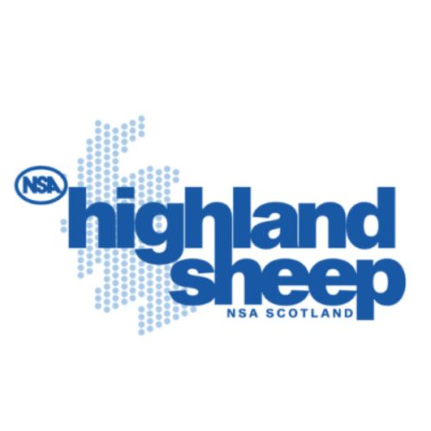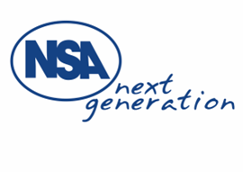
NSA Highlandsheep 2025

Tuesday 10th June 2025
Midfearn Farm, Ardgay, Ross-shire, IV24 3DL

Kindly sponsored by
PRIZE FUND £1400015915

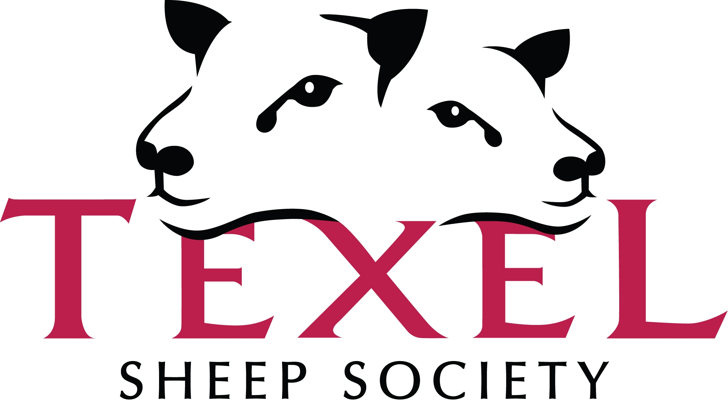

And Supported by

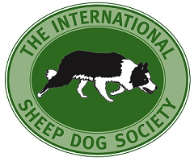
&
British Wool

You are invited to take part in the above competition.

INTRODUCTION
The NSA Highlandsheep 2025 Organising Committee are running a NSA Next Generation Shepherd of Year Competition at Midfearn Farm, Ardgay, Ross-shire, IV24 3DL on Tuesday 10th June 2025. We invite all young people who reside in Scotland, aged up to 26 years of age on 28th July 2026 to enter. The winner will receive £300 plus a trophy. The winner will also get the chance to represent NSA Scotland at the UK finals held at NSA Sheep Event 2026 at Malvern on 30th July 2024, if you are still 26 or under on that date.

PRIZES
The overall competition is generously sponsored by the Texel Sheep Society
1st £300 + Trophy, 2nd £200, 3rd £100, 4th £50. 5th £30, 6th £20. The highest placed competitor under the age of 21 will also receive a prize of £100.

The International Sheep Dog Society are also supporting those entrants competing in the sheep dog handling element of the competition and the highest place will receive the following prize money of 1st £200; 2nd £150; 3rd £100; 4th £50; 5th £50; 6th £25 & 7th £25.

British Wool are providing a £50 voucher towards the cost of a shearing and wool handling training course, for the highest placed competitor in the shearing element.

FORMAT OF COMPETITION AT NSA HIGHLANDSHEEP 2025

All competitors will be expected to be able to carry out FIVE of the six tasks listed below:
- Prime Lamb Selection
- Shear two sheep. (You must have a British Wool Blue Seal Certificate, the certificate to be produced on the day).
- ATV Handling, complete a set course.
- Give examples of correct foot care techniques / handling, vaccinating & dosing (e.g. work out correct weight of ewes for dosage of wormer and correct examples of injection sites). (This task is compulsory for all).
- Answer questions on flock management and health issues (This task is compulsory for all).
- Sheepdog Handling – A test at gathering, moving and penning sheep. (You must bring your own sheepdog)

IMPORTANT INFORMATION

- Maximum age of 26 years on 28th July 2026
- You must reside in Scotland.
- Entry to the competition is free.
- Closing date for entry – Friday 2nd May 2025.
- A maximum number of 20 entries can be accepted. They will be selected using the information you supply on your entry form.
- The Judge’s decision is final.
- The competition will start at 1.00pm on Tuesday 10th June 2025.
- The prize giving will take place at 3.30pm at the main NSA Highlandsheep 2025 event on Wednesday 11th June at Midfearn Farm, Ardgay, Ross-shire, IV24 3DL. An entrance ticket to NSA Highlandsheep 2025 will be sent to you with your competitor pack.
- Prize money will be paid in cash at the award ceremony on Wednesday 11th June 2025.
- The highest placed Young Shepherd will represent NSA Scotland at the UK finals to be held at NSA Sheep 2026 in Malvern on the 28th July 2026. NSA Scotland will cover travel and accommodation costs.

I look forward to receiving your entry. In the meantime, if you have any queries, please do not hesitate to contact me.

Euan Emslie, NSA Highlandsheep 2025 Event Organiser

Euan Emslie, NSA Highlandsheep 2025 Event Organiser
3 Briar Close, Newport, Brough, East Yorkshire, HU15 2QY
or
Email: euanemslie053@gmail.com Mobile: 07902 540985

NSA NEXT GENERATION SHEPHERD OF YEAR COMPETITION

NSA Highlandsheep 2025

Tuesday 10th June 2025
Midfearn Farm, Ardgay, Ross-shire, IV24 3DL

Kindly sponsored by
PRIZE FUND £1400

And Supported by

&
British Wool

ENTRY FORM

Name
Address
Post code
Date of Birth
Age on 11/06/25 |  | Age on 28/07/26
Tel No |  | Mobile No
Email

Qualifications/Certificates held: (if applicable)

Details of work experience/jobs: (if applicable)

Current Employer and job role: (if applicable)

For Students: Current course being followed:

One reference - Name and Address:

Please select FIVE of the six tasks below, these will be the tasks that you will complete on the day. Please note the health questionnaire & husbandry skills sections are compulsory:
 | Tick 5
- Prime Lamb Selection
- Shear two sheep. (You must have a British Wool Blue Seal Certificate, the certificate to be produced on the day).
Please tick to indicate if you have a BWMB Blue Seal certificate.

- ATV Handling, Daily preparation and safe use of an ATV with trailer, transporting stock and complete a set course.
- Demonstrate husbandry Skills. Give examples of correct foot care techniques / handling, vaccinating & dosing (e.g. work out correct weight of ewes for dosage of wormer and correct examples of injection sites). (This task is compulsory for all). | 
- Health & flock management questionnaire - Answer questions on flock management and health issues (This task is compulsory for all).
- Sheepdog Handling – A test at gathering, moving and penning sheep. (You must bring your own sheepdog).

Please note that entries are limited, and if oversubscribed, selection for the competition will be made by the organisers.

ENTRY FREE OF CHARGE - CLOSING DATE FRIDAY 26th MAY 2025

Signed ………………………………………….. Date ……………………………………………..
Please send completed applications to – Euan Emslie, NSA Highlandsheep 2025 Event Organiser, 3 Briar Close, Newport, Brough, East Yorkshire, HU15 2QY or
Email: euanemslie053@gmail.com Mobile: 07902 540985

