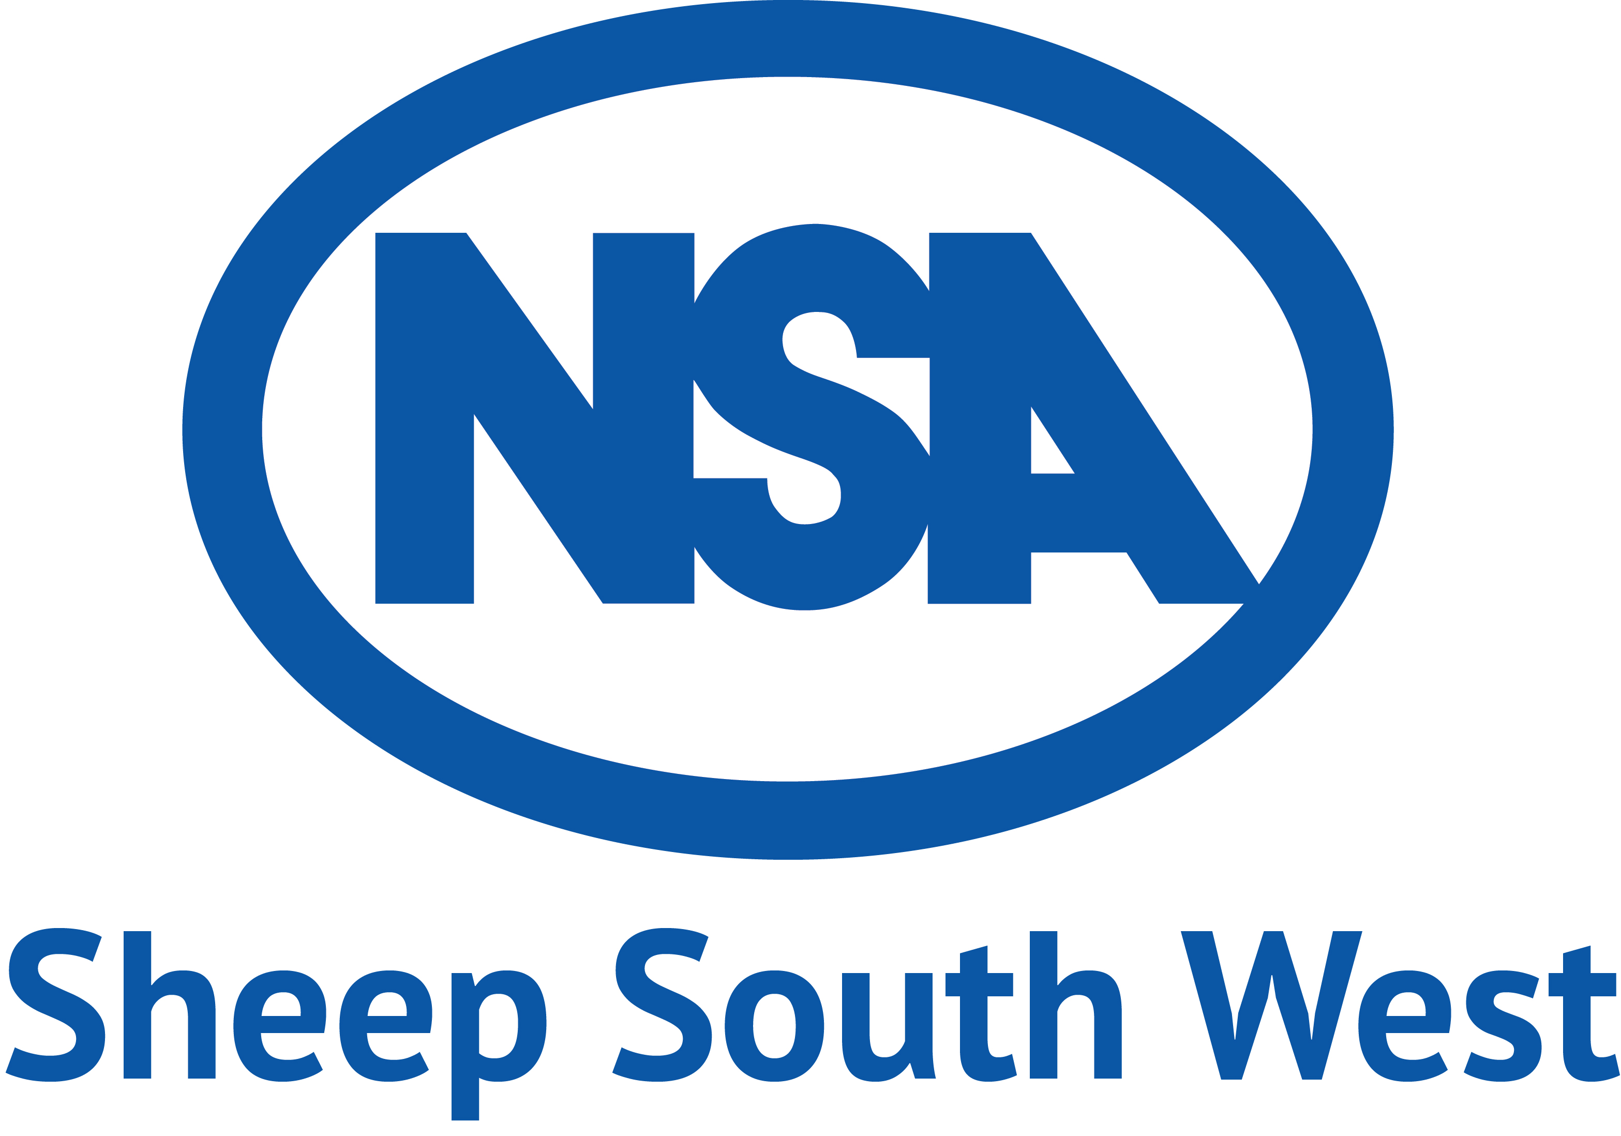

National Sponsors -

- Prominent Stand Space with 20% discount (up to 12m x 3m indoors, unlimited outside) – amount to be agreed with Sue Martyn includes 1 x double electric socket.
- 2 banners displayed.
- 4 free passes.
- 2 tickets for the Sponsors Lunch.
- Logo on sponsors page of the event programme and the webpage, also on the item sponsored as above.
- Editorial within the event programme.
- Promotion via event commentaries on the day.

Sponsorship - £750.00 + VAT

Regional Sponsors -

- Prominent Stand Space – (not included).
- 1 banner displayed.
- 2 free passes.
- 2 tickets for the Sponsors Lunch.
- Logo on sponsors page of the event programme and the webpage, also on the item sponsored.
- Editorial within the event programme.
- Promotion via event commentaries on the day.

Sponsorship - £250 + VAT

